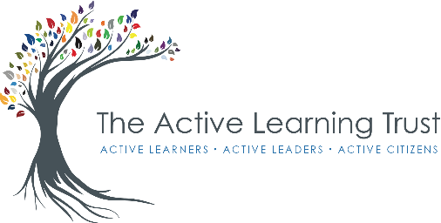
Headteacher: Mrs K. Coates
Burnsfield Street
Chatteris
Cambridgeshire
PE16 6ET
Tel: 01354 692323
Email: office@kingsfield.cambs.sch.uk

July 2021

Dear Parents / Carers,

During your child’s time here at Kingsfield, we will be providing a range of activities to support learning. Some of these activities require your permission as the parent/carer – a summary is provided below. Please read the summary and sign the slip at the end of this letter if you agree to give your permission. Please note, that unless you notify us of a change of circumstances, any permission given by yourselves will last for the time your child attends Kingsfield Primary School.

PG Rated Films
In English lessons, we often compare a text to a film. As we are only allowed to watch films rated U, this limits the film titles we can use as part of our education. We often use films to look at settings and to make our writing more imaginative; therefore, we feel that allowing the children to watch PG films in school would improve their work. The staff ensure that any films or extracts they show do not contain unsuitable materials and are appropriate for their class age and group.

Town Studies
One of our major resources for teaching history, geography and environmental studies, is the town of Chatteris itself. By walking around the town, many of the skills we want to teach our pupils are given real meaning. All year groups take advantage of this free resource during the course of a year and we would like your formal permission to occasionally take your child off the school premises. All groups leaving the schools grounds are, of course, well supervised, and most excursions would last about an hour. Any child without written permission would be left in school with another class.

Withdrawal of Consent
You have the right to change your mind in relation to any of the consents that you have provided below at any time. To withdraw your consent to any of those provided below, please put this in writing to the school office. Once we have received notification that you have withdrawn your consent, we will no longer process this information for the purpose or purposes you originally agreed to. Further information about your rights are recorded in our Parents/Carers Privacy Notice and Pupil Privacy Notice.

Yours sincerely,
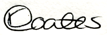
Mrs K. Coates

--------------------------------------------------------------------------------------------------------------------------------------------
I / we hereby agree to my child taking part in the following activities:
PG Rated Films and Town Studies (Please tick those you are in agreement with)
Child’s name: ____________________________________________ Class: ______________________

Parent/Carer’s name: _____________________________________ Date: ______________________

Relationship to the child: __________________________________

